Press release

From July 14 – 18, Ctrl Lab Montreal Art House is pleased to present the launch of Mad for Cows series by Canadian photographer Christa Fairchild which examines the shift from traditional pastoral composition to contemporary style and fresh sense of perspective.

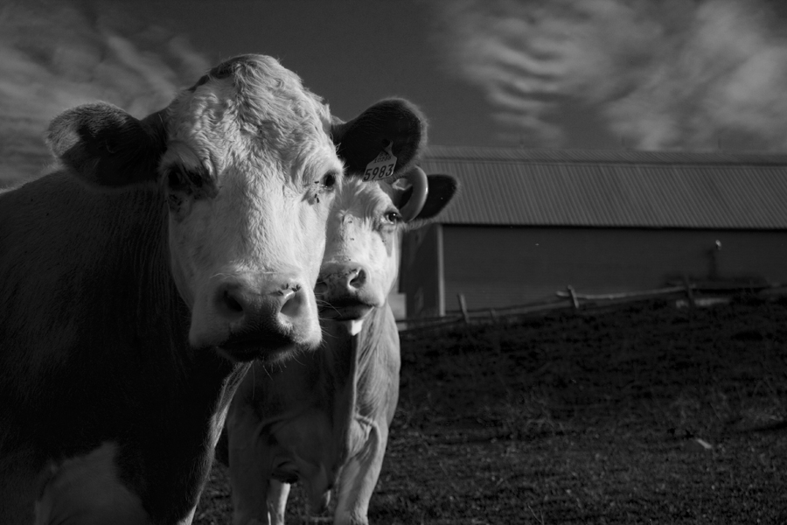
From Wednesday July 14 to Saturday July 18 Ctrl Lab, located at 3634 St. Laurent, will be showing photographs from Canadian artist, Christa Fairchild. The vernissage and “meet the artist” will be hosted on Thursday, July 15 from 5:30 – 9pm. There will be framed, mixed media, as well as unframed photos available.
The Gossip Mongers, Christa Fairchild

Change the viewpoint and you shift perspective. Through photography the artist examines the results of changing viewer’s standpoint and how it affects our emotional response.

Inspiration for her photography comes from nature – from close ups of plants to the great stone expanses of the desert. With the bare minimum, she conjures up the essence of the subject without expressing the whole. Intimacy is created with the subject by using depth of field and light. In this way the viewer’s eye is drawn to the delicate details.

“What I capture on camera inspires and motivates us to stop and look, with a fresh perspective,” explains Ms. Fairchild, “and we appreciate what we don’t always see at first glance. The photography I do always brings happiness and feel-good factor.”

About the artist, Christa Fairchild
Montreal born, Canadian fine art photographer and interior designer, Christa Fairchild, knows how to live with art. She creates “easy access” works that bring light, colour and ambiance to any room. You can see more of her work at www.fairchild-designs.com.

About Ctrl Lab Montreal Art House
Ctrl Lab is an art gallery and event space dedicated to disseminating the work of emerging and established artists, while providing the Montreal arts community with a venue for events in a non-traditional gallery setting. Our aim is to stimulate new dialogue and challenge audiences with diverse interdisciplinary work. Conveniently located at 3634 St. Laurent Boulevard (corner Prince Arthur), Ctrl Lab is open to rent for artists and curators for professional solo or group shows as well as for private events.

Contact: Andrea Velazquez, (514) 927-0611 Dir. of Marketing, Ctrl Lab, Email: marketing@ctrllab.com

